**Behavior Consequences**

* Warning
* Silent Lunch
* Parent/Guardian Phone Call or Email
* Referral

**Making good choices will help prevent Behavior Consequences. The order may change depending on the severity of the offense and teacher discretion.**

**90-100 A**

**80-89 B**

**70-79 C**

**60-69 D**

**60 and below F**

**GCS Grading Policy**

Dear Parents and Students,

I would like to extend a warm welcome to Brown Summit Middle Center for Advanced Academics for the 2022-2023 school year!! I am excited about this new year, and I hope that you are too! I teach Language Arts, where your child will focus on intensive reading and writing skills as indicated through the North Carolina Standards. To meet these standards, we will explore the literary genres using a variety of print and non-print texts. One of our resources we will use this year is *MyPerspectives*. This instructional framework aims for students to be “College and Career Ready” with strategies that meet their academic needs. Students will analyze text, cite evidence, and respond critically about learning. Students will read a variety of texts, both print and nonprint. Students will read several self-selected novels this year that coincide with the units. Students will also have Daily Grammar Practice activities.

**Homework** will be assigned on an as-needed basis in order to reinforce skills. When assigned, homework should be completed and turned in on time through Canvas and/or classroom turn-in.

Students should aim to read about 30 minutes each night with a text that coincides with our units. Students will have weekly reading responses based on their texts.

**Classwork** should be completed and turned in through Canvas and/or classroom turn-in upon the day it’s assigned in class. Students may need to complete classwork assignments at home.

All student work will be scored using a variety of rubrics. Students and parents will be notified of missing assignments.

Assignments and other important information can be found on Canvas. Parents have the ability to enroll in Canvas as parent observers.

Students are encouraged to reach out if they need assistance regarding assignment requirements.

**Please consult the Brown Summit Middle School Student Handbook and GCS Handbook for additional information for the upcoming school year**.

Mrs. McCarthy’s Classroom Newsletter

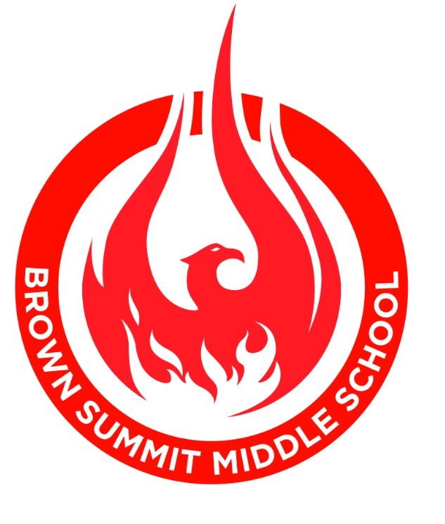

# Homework and Classwork

# Advanced ELA 8 and English 1

Welcome Back!

banner with apples and crayons

### Brown Summit Middle School

Center for Advanced Academics

**Summer Reading Projects**

Summer Reading Essays should be completed by Friday, September 9. Summer Reading Projects should be completed by Friday, September 9. I will be going over this with students during the first week. Students will also be given information for their Book Talk during the first week.

**Forms**

*Please check our* [*BSMS*](https://www.gcsnc.com/Page/31) *website often, especially for any forms or surveys to complete.* Please keep us updated with your most current contact information to receive our announcements throughout the year.

**Other**

*Please check Canvas and PowerSchool often for your child’s progress.

*Weekly emails will be sent out on Monday evenings detailing the events for the week. *Please make sure your email is updated if you want to receive these emails.

*Phones and wireless ear buds are to be in student’s locker during instruction time. If you need to contact your child, please call the school.

## Upcoming Events

There are four main categories for scoring assignments:

* + **Performance**

**(Assessments/Projects) 30%**

* + **Quizzes 25%**
  + **Classwork**

**(What we complete in class/online,**

**including Participation) 35%**

* + **Homework 10%**

Students can expect reading assignments, writing assignments, Daily Grammar Practice, conferencing regularly with me, and Speaking and Listening practice.

Rubrics will be provided for various assignments to outline expectations and/or mastery of a skill, concept, or task.

Rubrics will be used to assess criteria such as, but not limited to, Time Spent, Grammar and Mechanics, Assignment Turned-in On Time, Legible, Heading, and Following Directions.

We will be using Canvas for our Student Management System. Here, you will have access to assignments and announcements, as well as other useful links.

We will also send out weekly grade-level announcements through Remind and email.

**Late Work Policy** for homework and classwork:

1 Day Late—10% deduction

2 or More Days Late—30% deduction

Work more than 1 week late will not be

accepted and scored as a zero.

***\*Exceptions are on a case-by-case basis depending on the assignment type.***

***\*Teachers reserve the right to alter this depending on the assignment type.***

***\*Assignments with extended due dates (such as projects) do not fall into the Late Work Policy for this class.***

## Materials For LA Class

* 1, 2-pocket folder with middle prongs
* 1 Composition Notebook

Please be assured that our goal is to work with parents the way we would want our children’s teachers to work with us! I feel confident that by working together we can make this year a very successful one. I look forward to meeting and working with all of you. Please feel free to contact me if you have any questions or concerns.

Contact Information:

**Phone: (336-656-0432).**

**Email:** [**mccartl@gcsnc.com**](mailto:mccartl@gcsnc.com)

**Remind 101: Advanced ELA 8**

[**https://www.remind.com/join/3dk8ac**](https://www.remind.com/join/3dk8ac)

**English 1: @LMcEng1**

[**https://www.remind.com/join/6c72hge**](https://www.remind.com/join/6c72hge)

If at any time during the school year you feel a conference is necessary, please get in touch with Sonja Sloan, School Counselor, ([sloans@gcsnc.com](mailto:sloans@gcsnc.com) or 336-656-0432), to set up a convenient time to meet with your child’s team of teachers.

Middle school can be a very exciting place for students. Middle school is also about transition and change. It is important that we all work together as a team to help our students be successful in school, as well as in life! In no time, we will be talking about your child’s high school options! Please feel free to call if you have any questions or concerns about this new year.

**Let’s Have a Great Year!!**

#### L. McCarthy

# Grade Distribution

Mrs. McCarthy’s Classroom Newsletter Page 2